**LAPORAN MINGGUAN PEMROGRAMAN 1**

**PRAKTIKUM ke 4**

**Nama : Aldi Reza Sastrawan**

**NPM : 4513210004**

1. **Program 1**

public class manusia{

public String nama;

public static void main(String[]args){ //main method

manusia orang = new manusia(); //menciptakan objek orang

orang.setNama("Aldi");

System.out.println ("Namaku adalah="+orang.getNama());

}

public void setNama(String namaku){ //method berparamenter

this.nama=namaku;

}

public String getNama(){

return this.nama;

}

}

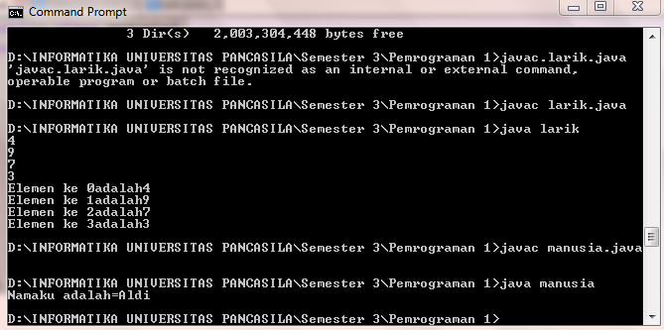

1. Program 2

public class Mahasiswa {

intnilai;

public static void main(String [] args) {

Mahasiswa orang = new Mahasiswa();

orang.setNilai(100);

System.out.println("Nilaikuadalah = " + orang.getNilai());

}

public void setNilai(intnilaiku) {

this.nilai = nilaiku;

}

publicintgetNilai() {

returnthis.nilai;

}

}

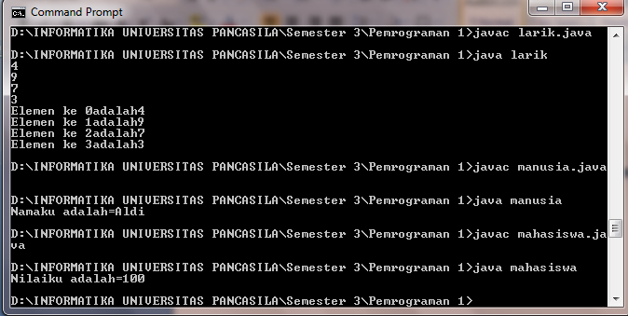

1. Program 3

public class larik{

public static void main (String[]args){

int [] data={4,9,7,3};

int i;

for (i=0;i<4;i++){

System.out.println(data[i]);

}

for (i=0;i<4;i++){

System.out.println("Elemen ke "+i+"adalah"+data[i]);

}

}

}

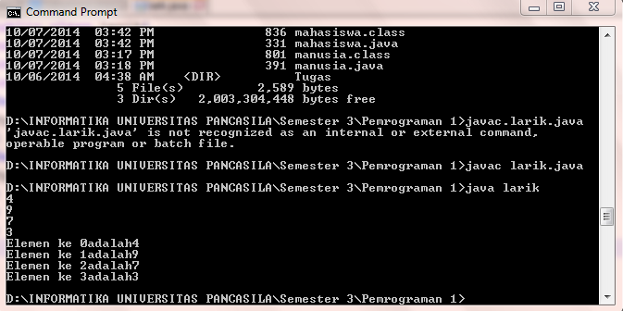

1. Program 4

public class larikstring{

public static void main (String [] args){

String[]dataString = {"Makan","Tidur","Mandi"};

int i;

for (i=0; i<3; i++){

System.out.println(dataString[i]);

}

for (i=0; i<3; i++){

System.out.println("Hobisaya = "+dataString[i]);

}

}

}

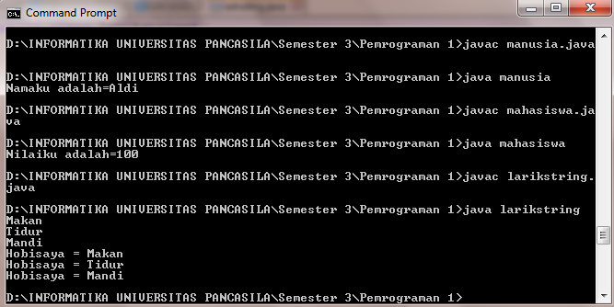

1. Program 5

importjava.util.Scanner;

public class intArray{

public static void main(String [] args){

String [] angka;

int i;

intbanyak;

Scanner input = new Scanner(System.in);

System.out.print("MasukkanBanyakangka = ");

banyak = input.nextInt();

for(i=0;i<banyak;i++){

System.out.print("MasukkanAngka = ");

angka = input.nextInt();

}

}

}

1. Program 6

importjava.util.Scanner;

public class intArrayInput{

public static void main(String [] args){

intangka[] = new int[10];

inti,banyak;

intjumlah;

jumlah=0;

Scanner input = new Scanner(System.in);

System.out.print("MasukkanBanyakangka = ");

banyak = input.nextInt();

for(i=0;i<banyak;i++){

System.out.print("MasukkanAngka = ");

angka[i] = input.nextInt();

jumlah = jumlah + angka[i];

}

System.out.println("Jumlahnyaadalah " + jumlah);

}

}

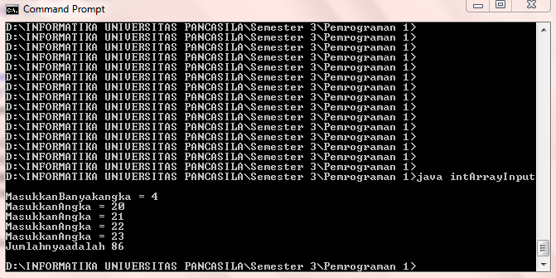

1. Program 7

importjava.util.Scanner;

public class outputArray{

public static void main(String [] args){

intangka[] = new int[10];

inti,banyak;

intjumlah;

jumlah=0;

Scanner input = new Scanner(System.in);

System.out.print("MasukkanBanyakangka = ");

banyak = input.nextInt();

for(i=0;i<banyak;i++){

System.out.print("MasukkanAngka = ");

angka[i] = input.nextInt();

jumlah = jumlah + angka[i];

}

System.out.println("Jumlahnyaadalah " + jumlah);

if(jumlah%2==0){

System.out.println("\nJumlahtermasukbilangangenap");

}

elseSystem.out.println("\nJumlahtermasukbilanganganjil");

}

}

